**Diamond Shop System**

**I/  Background**

**Issue:**

Manual Order Management: Handling orders manually through paper documentation can lead to mistakes, information loss, and difficulty in retrieving necessary data.

Ineffective Product Management: Keeping track of inventory, product information, and related data also poses challenges. In the diamond business industry, efficiently managing sales transactions and related processes is crucial.

**Benefits:**

Increased Efficiency and Accuracy in Order Management: The software automates the buying and selling process from order placement to delivery, minimizing errors and enhancing accuracy. Efficient Product and Inventory Management: The software facilitates automatic and effective tracking of inventory, product information, and related data.

Data Analysis and Reporting Tools: The software provides robust tools for data analysis and reporting, simplifying business decision-making and ensuring accuracy.

**II/ User classes & Characteristics**

1. **Customers:** Customers are the main people who use the website to search, view and buy jewelry. They need a user-friendly and easy-to-use interface, as well as features like advanced search, product reviews, and secure payments.

2. **Store management:** Store management will use the website to manage products, orders and customer information. They need features like inventory management, order tracking, and customer information management.

3. **Sales staff**: Sales staff can use the website to help customers search for products, provide consultation and process orders. They need features like searching for products, viewing product information, and processing orders.

4. **Technical staff:** Technical staff will use the website to maintain and improve the website. They need features like system management, traffic monitoring, and technical troubleshooting

5. **Storage** **manager**: The Storage Manager should ensure that the data stored is accurate and consistent over its entire life-cycle.The Storage Manager should provide backup and recovery options to protect data from loss or corruption.

6. **Transporter**: Professionals security have high responsibility for protecting the diamonds, move with specialized vehicles. They use app to update the status of the route

**III/ Methods**

**1.Direct observation**

**1.1 Customer**

* Survey objective: Understand customers' needs, desires, and behaviors when accessing and using the website.
* Factors that need to be investigated:
* Visit purpose: Search for products, information, shopping, etc.
* User experience: Easy to use, friendly interface, page loading speed.
* Favorite features: Search, filters, product comparisons, reviews and comments.
* Common problems: Page errors, difficulty finding products, unclear information.
* Satisfaction level and suggestions for improvement.

**1.2 Store Management**

* Survey objective: Understand the requirements and expectations from store managers to effectively manage and operate business operations.
* Factors that need to be investigated:
* Product management tools: Add, edit, delete products, manage inventory.
* Report and statistics: Sales, traffic, best-selling products.
* Integrate with other systems: ERP, CRM, warehouse management system.
* Security and decentralization requirements: Decentralize rights to employees, secure customer data.

**1.3 Sale Staff**

* Survey objective: Understand the needs and difficulties of sales staff when using websites to support customers.
* Factors that need to be investigated:
* Customer support process: Product search, product information, ordering process.
* Sales support tools: Online chat, order management, tracking potential customers.
* Common problems: System errors, difficulty finding information.
* Suggest improvements to support sales more effectively.

**1.4 Technical Staff**

* Survey objective: Understand your website's technical and scalability requirements from the technical team's perspective.
* Factors that need to be investigated:
* Performance requirements: Page loading speed, ability to handle large amounts of traffic.
* Technical features: API integration, data management, data backup and recovery.
* Security and safety: Prevent attacks, protect customer data.
* Easy maintenance and updates: Maintenance process, system upgrades, error correction.

**1.5 Storage Management**

* Survey objective: Understand the specific needs of gemstone valuation and management, as well as warehouse management.
* Factors that need to be investigated:
  + Valuation process: Record information, evaluate quality, store valuation data.
  + Warehouse management: Inventory tracking, import and export management, inventory.
  + Data integration: Link pricing information to product information on the website.
  + Support tools: Valuation software, image management and detailed information about gemstones.

**1.6 Shipping**

1. Survey objective: Understand freight shipping requirements and processes to ensure on-time and safe delivery.
2. Factors that need to be investigated:
   1. Shipping process: Ordering, packaging, delivery, order tracking.
   2. Tracking system: Track orders, update shipping status.
   3. Integrate with shipping partners: Cooperate with shipping units, update delivery information.
   4. Common problems: Late delivery, damaged or lost goods.
   5. Suggested improvements: Improve the speed and reliability of shipping services, improve customer experience.

**2.User interface analysis:**

* Use these **sources** to analyze user interface

[Buccellati jewellery Shop](https://www.buccellati.com/en_us/)

[vnj jewelry](https://trangsucdaquy.vn/)

* Objects accessing the interface

**1. Regular Buyers:**

* **Register and Login**

Register an account: Customers can create a new account by email, phone number or through social networks.

Login: Customers can log in to the system to manage personal information and purchase history.

* **Personal Account Management**

Personal information: Update and manage personal information such as name, address, phone number, and email.

Change password: Allows you to change your password and manage account security.

Purchase history: Review previous purchases and current order status.

* **Search and Browse products**

Advanced Search: Search for diamonds by various criteria such as size, color, clarity, and price.

Product filter: Filter products by specific criteria to easily find the desired product.

Favorites list: Store favorite products to review later.

* **Product information**

Product description: Provides detailed information about diamonds such as carat, color, clarity, and cut.

Certification: Shows the diamond's certification from reputable organizations such as GIA (Gemological Institute of America).

Images and Videos: High-quality images and 360-degree videos of diamonds so customers have a clear view of the product.

* **Consulting and Support**

Live Chat: Online support via live chat to answer customer questions.

Phone and email support: Other support communication channels such as phone and email.

Personal consultation: Make an appointment for a personal consultation with a diamond expert.

* **Payment**

Shopping Cart: Manage selected products in the shopping cart.

Safe payment: Supports many safe and secure payment methods.

Discount codes and promotions: Apply discount codes and view available promotions.

* **Form delivery**

Choose a shipping method: Shipping options and delivery times.

Order tracking: Update order status

* **Reviews and Feedback**

Product reviews: Allow customers to rate and comment on purchased products.

Service feedback: Send feedback about your shopping experience and service quality.

* **Loyalty Program**

Bonus points: Earn bonus points from transactions to receive incentives or gifts.

Membership level: Upgrade membership with special benefits.

* **Security and Privacy**

Privacy policy: Provide clear information about privacy policies and handling of customers' personal data.

**2. Jewelry Retailers:**

* **Register and Login**:

Create and manage merchant accounts.

Login when the account is existed.

Personal and business information: Update personal information and contact information.

* **Customer management:**

Customer information: Store and manage customer contact information.

Transaction history: Review each customer's purchase history.

Feedback and reviews: Manage feedback and reviews from customers about products and services.

* **Sales report:**

Create reports on revenue, sales, and other business metrics.

* **Customer support**

Live chat and online support: Provide customer support services via live chat.

Phone and email support: Manage and track phone and email support requests.

FAQ and support documents: Create and manage frequently asked questions and guidance documents for customer support.

* **Payments and invoices**:

Manage payment methods and issue invoices to customers.

* **Transportation and Delivery Management**

Shipping options: Set up shipping methods and shipping rates.

Shipping tracking: Track the shipping process and update delivery information for customers.

**3. Store manager**

* **Register and Login**:

Create and manage merchant accounts.

Login when the account is existed.

Update personal information.

* **Product Management**

Add and edit products: Add new, update detailed information of diamond products such as carat, color, purity, cut, and selling price.

Inventory management: Monitor and update inventory quantity of each product.

Product images and videos: Upload and manage high-quality images and videos of diamonds.

* **Promotion and Marketing Campaign Management**

Create discount codes: Create and manage discount codes for customers.

Promotions: Set up promotions and special offers..

* **Financial management**

Financial reports: View financial reports related to revenue, costs, and profits.

* **Transportation and Delivery Management**

Shipping options: Set up shipping methods and shipping rates.

Shipping tracking: Track the shipping process and update delivery information for customers.

**4. Storage manager**

**- Register to import warehouse:**

Record details about quantity, type of diamonds, date of import, supplier and warehouse value.

Automatically increase inventory quantity when new inventory is received.

**- Register for delivery:**

Record details about quantity, type of diamonds, date of shipment and consignee.

Automatically deduct inventory quantity when there is a release.

**- Planning inventory:**

Schedule regular inventory or unexpected inventory.

Record and update data on the system.

**- Inventory management:**

Displays diamond inventory by type, size, color, etc.

Warning when inventory drops below minimum level.

**- Automatic ordering:**

Automatically create purchase orders for distributors when the number of diamonds in stock falls below the safety threshold.

**- Manage storage locations:**

Record and track the storage location of each diamond in the warehouse.

Record appropriate temperature and humidity reports for diamonds every day.

**- Reporting and Analysis:**

Generate detailed reports on real-time inventory status.

Generate reports on incoming and outgoing warehouse transactions, including quantity, value and time for store management.

**- Trend analysis:**

Automatically analyze input and output data to predict demand trends and plan purchases.

**- Damaged Goods Management:**

Record damaged goods:

Record and monitor damaged or substandard goods.

Plan and implement measures to handle damaged goods such as return to supplier or destruction.

**5. Shipping**

**3.Survey**

* **What is the main color tone for your interface?**

Use something that matches the diamond like : yellow, white, blue ….

* **What are the user trends you want to reach?**

according to market trends but need to have different that will create a mark for our own business

* **How do you categorize diamonds ?**

Diamonds are separated into five types: Type IaA, Type IaB, Type Ib, Type IIa, and Type IIb

* **How many payment methods ? What are they ?**

Local banking and visa card,cash

* **Does it need to give personal information to access or buy diamonds ?**

Yes, need information to storage bill for every transaction if customer

           need to access date and seek an origin

* **How many departments are there ? (separate role follow departments information and buyer)**

There are 6 departments (role) separate follow departments information and buyer

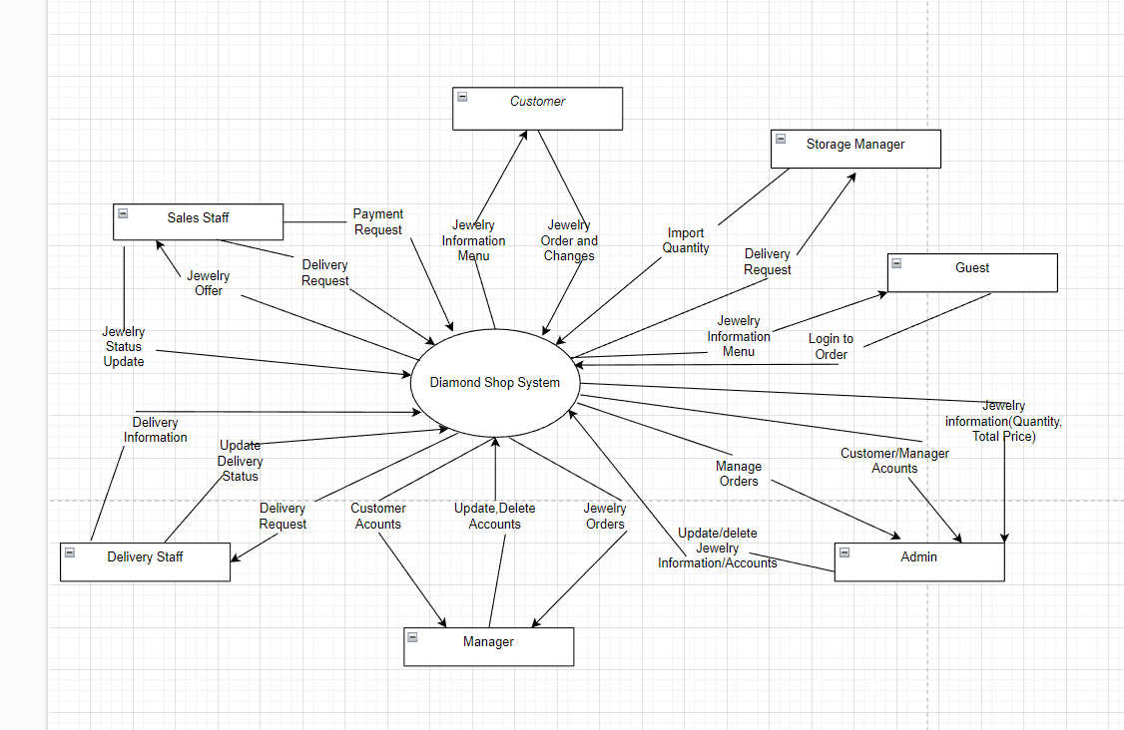

**IV/ Vision Statement:**

*Vision statements for a diamond shop system outlines the long-term aspirations and goals of the business :*

   - As Sales staff who want to be the single most desirable brand for fine jewelry and service, making customers look and feel their very best. To become the world's most recognized jewelry brand, the system has to update. The system should be passionate for excellence, customer-centricity, and constant innovation.

   - As a Store manager who needs to know vision is crucial for business success. It inspires employees and impacts your business positively. Consider your shop's unique qualities and create a vision that reflects your aspirations. Need a panel which can see every information of the system that is easy to access and use. So it can avoid unexpected problems like lost information or wrong information ….

- As Admins: who need to know how to manage the system's technical and administrative aspects.To maintain a robust and efficient system that supports all operations smoothly. We strive for excellence in data management, ensuring security and accuracy while enabling easy access and updates to meet the dynamic needs of our business.

- As Transporters who need to be responsible for the delivery and logistics of products. We envision a streamlined logistics process that guarantees the timely and safe delivery of our products. Our system should support real-time tracking and efficient coordination, ensuring that our jewelry reaches our customers in perfect condition, enhancing their overall experience.

- As Customers that the end-users purchase our products. We aspire to provide an unparalleled shopping experience where every customer feels valued and special. Our vision is to offer a user-friendly platform that ensures a smooth browsing and purchasing process, backed by exceptional customer support and personalized services.

**V/ Use Case Specification**

|  |  |  |  |
| --- | --- | --- | --- |
| **ID and Name** | DSS 01 - Order Jewelry | | |
| **Created By** | Nguyen Nhat Nam | Date created | 27/05/2024 |
| **Primary Actor** | Guest/Customer | Secondary Actors | Store manager, sales staff, diamond system |
| **Description** | A Guest/ Customer accesses the Diamond shop to view the menu of jewelry , search and select items he wants to buy, then choose delivery methods, use discounts and choose payment methods. | | |
| **Trigger** | A Guest/ Customer wants to buy jewelry online | | |
| **Preconditions** | PRE -  A guest must login/register into diamond shop system | | |
| **Postconditions** | POST - 1 Jewelry orders stored in system  with a status of “Accepted”  POST - 2 Storage of available jewelry items with 4C Standard  POST - 3 Ensuring safe delivery to customers | | |
| **Normal Flow** | 1.0 Order a Single Jewelry  1. Customers ask to view menu and jewelry’s price change  2.  Customers menu of available Jewelry items and the daily price.  3. Customers select one or more Jewelry items from the menu.  4. Customers indicate  that the Jewelry order is complete.  5.  System displays ordered menu items, individual prices, and total price, including taxes and delivery charge.  6. System  will send customers a product quality inspection certificate according to 4c standards  7.  System displays available delivery times for the delivery date  8.  Customers selects a delivery time and specifies the delivery location  9.  Customers specify payment methods.  10. System confirms acceptance of the order. 11. System sends Patron an email message confirming order details, price, and delivery instructions. 12. System stores order, sends Jewelry items information to Cafeteria Inventory System, and updates available delivery times. | | |
| **Alternative Flows** | 1.1 Order multiple identical Jewelries 1.      Customers require a diamond inspection certificate and safe delivery  1.2 Order multiple Jewelries       1.        Customers ask to exchange or return Jewelries. | | |
| **Exceptions** | 1.0.E1 Requested date is today and current time is after today’s order cutoff time  1. System informs Customer that it’s too late to place an order for today. 2a. If Customer cancels the jewelry ordering process, then System terminates the use case. 2b. Else if Customers requests another date, then System restarts use case.  1.0.E2 No delivery times left 1. System informs Customer that no delivery times are available for the jewelry date. 2a. If Customer cancels the meal ordering process, then System terminates the use case. 2b. Else if Customer requests to pick the order up at the diamond shop, then continue with normal flow, but skip steps 7 and 8.  1.1.E1 Insufficient inventory to fulfill multiple Jewelry order  1. System informs Patron of the maximum number of identical meals he can order, based on current available inventory. 2a. If Customer modifies the number of Jewelry ordered, then Return to step 4 of normal flow. 2b. Else if Customer cancels the meal ordering process, then System terminates use case | | |
| **Priority** | High | | |
| **Frequency of Use** | About 1000 users, on average  1-2 users buy jewelry. Because jewelry is expensive, users just access the website to see the jewelry. | | |
| **Business Rules** | BR-1: Receiving purchase requests from after 8:00 AM to 9:00 PM from Monday to Sunday. BR-2: Receiving invoices with a maximum quantity of 10 items/invoice. In case the invoice has more than 10 items or contains loose stone products, the sales staff must assist the customer BR-3: In case a customer orders the same item on multiple invoices and uses cash payment upon receipt, the sales staff is responsible for contacting the customer about the purpose of the order within 24 hours. after the order is recorded on the system. BR-4: In case an order for an individual does not have contact information on the system or is placed as a gift, the person placing the order must provide full and correct information about full name, address and contact information. BR-5: In case a customer has problems ordering diamonds or diamond-encrusted jewelry, sales staff or store managers must receive support within 15 minutes at most from the time the customer requests support. BR-6: Customers paying in cash must transfer a deposit in advance equal to 10% of the value of the order invoice and must receive an electronic deposit receipt via the system or Zalo to confirm with the delivery person. BR-7: Customers who pay by bank transfer after successful transfer must receive a receipt and related documents no later than 30 minutes from the successful transaction. BR-8: In case of domestic delivery, to customers' addresses close to the warehouse, the slowest delivery time is 5 days to 1 week in case of stock. For addresses far from the warehouse, it will take at least 2 weeks in case of stock, depending on shipping conditions. In the above delivery cases, all relevant documents and invoices must be provided to the customer after confirmation from the sales staff. BR-9: Domestic return policy is 48 hours from successful delivery and each product in the invoice can only be exchanged once within 48 hours in cases of damage caused by the manufacturer. , damage during transportation or goods that do not match the specifications, appearance, or quantity as ordered by the customer.  BR-10: In case the customer has applied for a voucher with a value of less than 500,000 VND, the return policy will still apply but will only refund based on item BR-7 and will not refund the voucher. | | |
| **Other Information** | 1.       Customers shall be able to cancel the jewelry ordering process before deposit time. If they cancel after deposit time they will lose deposit cost. 2. Customers can check the product quality after receiving the goods, and can investigate if they do not comply with the requirements when placing the order. | | |

|  |  |  |  |
| --- | --- | --- | --- |
| **ID and Name** | DSS02 - Create a Weekly Report | | |
| **Created By** | Ng Trung Viet Anh | **Date created:** | 27/05/2024 |
| **Primary Actor** | Sales staff | **Secondary Actors:** | Store manager |
| **Description** | A sales staff member generates a weekly report summarizing sales activities. | | |
| **Trigger** | A sales staff logs into the systems and receives a reminder about generating a weekly report | | |
| **Preconditions** | PRE-1. Sales staff members must login to the system and receive reminders of generating weekly reports. | | |
| **Postconditions** | POST-1. A weekly sales report is generated.  POST-2. The report is available for review by the store manager. | | |
| **Normal Flow** | Generate a Weekly Report   1. Sales staff members select the ‘Generate Weekly Report’ option in Generate Report Feature (GRF) . 2. GRF prompts to confirm or edit date range for reporting period. 3. Sales staff member confirms date range. 4. GRF retrieves all relevant sales data for a specified period. 5. GRF compiles data into a predefined report format including total sales, top products sold, weekly revenue, etc. 6. GRF displays a draft of a weekly report on screen for review. 7. Sales staff members review and approve drafts or make necessary edits. 8. Approved final version of the weekly report is saved in the system or export into excel files if needed and notification sent to the store manager. | | |
| **Alternative Flows** | A1: If there are discrepancies in data      1. System flags discrepancies for review by sales staff members.      2. Staff corrects any errors before finalizing the report. | | |
| **Exceptions** | E1. The day range in the report includes a holiday  1. The system displays an error message and prompts the user to correct the input**.** 2a. If sales staff cancels the process, then Generate Report Feature terminates use case.  2b. Else if sales staff request another day range, then GRF restarts use case.  E2. Weekly Report is already generated  1.The system informs sales staff that the weekly report is already generated for this week and asks sales staff if they want to update this report or not.  2a.If sales staff cancels the process, then the notification disappear  2b.Else if sales staff requests to update weekly report, then continue with step 4 | | |
| **Priority** | Medium | | |
| **Frequency of Use** | Every Monday. Peak usage load for this use case is 8:00 AM in local time | | |
| **Business Rules** | BR-1: The system should automatically remind sales staff to generate the weekly report every Monday at 8:00 AM  BR-2: 1 sales staff can only create 1 weekly report a week.  BR-3: The report must be filled in the previous day or within the limit is 2 days after the week's report in case of a sales staff absence on Monday.  BR-4: The weekly report must include total sales revenue, number of transactions, and average transaction value. BR-5: The report must detail the number of new customers, returning customers, and total customer visits. BR-6: The weekly report must include current inventory levels, restocked items, and items low in stock. BR-7: The report must analyze the effectiveness of ongoing promotions and discounts, including total discount given and sales uplift. BR-8: The report must include individual sales staff performance metrics, such as total sales, number of transactions handled, refund offer and customer feedback ratings. BR-9: The report must include comparisons with previous weeks' data to identify trends and patterns.  BR-10: In case of sales staff reports more than 2 days late from the date of annual reporting or not reporting more than 2 weeks will be fined on salary based on weekly penalties.  BR-11: In case the Staff quits his/ her job, the store manager must generate the employee's weekly report from the data from the date of the data collection to the end date. | | |
| **Other**  **Info** | None | | |

|  |  |  |  |
| --- | --- | --- | --- |
| **ID and Name** | DSS03 - View Cart | | |
| **Created By** | Huynh Nhat Thanh | **Date created:** | 27/05/2024 |
| **Primary Actor** | Customer | **Secondary Actors:** | Support system(Product, Inventory,....) |
| **Description** | Allows customers to check and manage products added to the cart before making payment. When the customer selects "View cart", the system will display a list of added products including detailed information about each product such as product name, image, price, quantity. Customers can perform operations such as updating product quantities, removing products from the cart and applying discount codes if available. | | |
| **Trigger** | * Select cart icon: Customers click the cart icon on the website or mobile app to view added products. * Select the "View Cart" link or button: The customer clicks the "View Cart" link or button from the menu or product page. * Complete adding products to cart: After adding products to cart, some systems will automatically display the cart or provide the option for customers to view the cart immediately. | | |
| **Preconditions** | **PRE-1** Customer is logged in (if necessary): If the system requires the customer to log in to view or manage their shopping cart, the customer must be logged in to their account.  **PRE-2** There is at least one product in the cart: The customer has added at least one product to the cart. If the cart is empty, the system will not be able to display the product list and may notify the customer that the cart is currently empty.  **PRE-3** System functioning properly: Essential system services such as product management, warehouse management, and other related services are operating normally to provide detailed information and cart updates.  **PRE-4** Stable network connection: Customers have a stable network connection to interact with the system and receive shopping cart updates. | | |
| **Postconditions** | **POST-1** Shopping cart updated and stored: Any changes made by the customer, such as updating product quantities or deleting products, are saved by the system and the shopping cart is updated in real time .  **POST-2** Total order value information is displayed accurately: The total value of the shopping cart, including product price, taxes, and shipping fees (if any), is calculated and displayed accurately to customers.  **POST-3** Discount code applied (if any): If the customer has entered a discount code, the system will check the validity of the code and apply the discount to the total order value.  **POST-4** Customers can proceed to checkout or save the shopping cart: After viewing and managing the shopping cart, customers can select "Checkout" to begin the payment process or save the shopping cart to continue shopping later.  **POST-5** Notify customers about cart status: If any problems occur, such as the product is no longer in stock, the system will notify the customer so they can adjust their cart. | | |
| **Normal Flow** | 1. Customer selects "View Cart": Customer clicks the cart icon or "View Cart" link/button from any page on the website or app. 2. Cart display system: The system retrieves customer cart information and displays a list of products added to the cart, including: Product name, Product image, Quantity, Price of each product products, Total price of each product, Total cart value (excluding taxes and shipping fees) 3. Customer checks cart: Customer reviews the products in the cart to make sure everything is as expected. 4. Customer updates cart: Customer can take the following actions:             +Update quantity: Customers can increase or decrease the quantity of each product.            +Delete products: Customers can remove unwanted products from the shopping cart.   1. Cart update system: The system updates the cart according to customer changes and displays the total cart value again. 2. Customers apply discount code (optional):             +Customers can enter the discount code in the corresponding box and press the apply button.            +The system checks the validity of the discount code and updates the total cart value if the code is valid.   1. The system calculates the total value of the cart: The system displays the total value of the cart including discounts, taxes and shipping fees (if any). 2. The customer decides on the next action:             +Select "Checkout": If the customer is satisfied with their shopping cart, they can select the "Checkout" button to proceed to the checkout process.           +Continue shopping: Customers can choose to continue shopping and add other products to the cart.           +Save cart (optional): Customers can choose to save the cart to continue managing or paying later. | | |
| **Alternative Flows** | 1. Shopping cart is empty              + The system confirms that the customer's shopping cart does not contain any products.             +Display notification: The system displays a notification to the customer that the shopping cart is empty, with suggestions to continue shopping and add products to the shopping cart.             +Redirection: The system can provide links or buttons for customers to return to the home page or product category page to continue shopping.   1. The product is out of stock              + Check warehouse status: The system checks warehouse status when customers update product quantities.             + Out of stock notification: If the product is no longer in stock or does not have the required quantity, the system displays an error message to the customer, informing that the product is out of stock or has insufficient quantity.             + Update cart: The system keeps the current quantity of products in the cart (if any) and requires the customer to adjust the quantity.   1. Invalid discount code              + Check discount code: The system checks the discount code when the customer presses the apply button.             + Invalid code notification: If the discount code is invalid or expired, the system displays an error message to the customer, explaining why the code is not accepted.             + Request to re-enter code: The system allows customers to re-enter another discount code or continue without a discount code. | | |
| **Exceptions** | 1. Lost network connection              + Connection loss detection: The system detects that the network connection is interrupted when the customer interacts with the shopping cart.             + Display error message: The system displays an error message to the customer, requesting to check the network connection.             + Retry: The system provides the option for customers to try again after the network connection is restored.   1. System error              + System error detection: The system detects that a system error occurred while the customer interacted with the shopping cart.             + Display error message: The system displays a general error message to the customer, apologizing for the problem and asking to try again later.             + Error recording: The system records errors in the log and sends a notification to the technical department to check and fix the problem. | | |
| **Priority** | High | | |
| **Frequency of Use** | Daily frequency: Most users will use the "View Cart" function every time they visit an e-commerce website or application to shop online. They often review their shopping carts to check and manage products before proceeding to checkout. | | |
| **Business Rules** | **BR-1** Maximum number of products in cart: Limit the number of products to 10 that a customer can add to the cart to ensure flexibility and the best shopping experience.  **BR-2** Cart retention time: Determines the time a cart is stored on the system before being deleted. This could be related to customer waiting times or business policies.  **BR-3** Shipping Rules: Defines the shipping rules that apply to the shopping cart, including shipping rates, available shipping methods, and delivery zones.  **BR-4** Promotion Rules:Rules and conditions apply to the use of discount codes or other offers related to the shopping cart.  **BR-5** Total order value calculation rules: Define how the total value of the cart is calculated, including product price, taxes, shipping charges, and applicable discounts.  **BR-6** Out-of-stock product check rule: The system must check before adding a product to the cart to ensure that the product is still in stock and has sufficient quantity.  **BR-7** Product quantity update rule: Defines how the product quantity is updated in the shopping cart when the customer changes the product quantity.  **BR-8** Login rule: Require customers to log in to their account to view and manage shopping cart (optional).  **BR-9** Save cart feature rule: Determines whether to allow customers to save their cart for future reuse, and how long the cart is stored. | | |
| **Other Information** | 1. Integration with "Save for Later" function: The system can provide a "Save for Later" feature to allow customers to save products they do not want to buy immediately into a separate list, helping to create a more flexible shopping experience. 2. Integration with the "Recommendations" function: The system can integrate the "Suggestions" function to suggest similar or suitable products to customers during the cart viewing process, increasing purchase opportunities.. 3. Integration with Analytics system: Data on the use of the "View Cart" function can be collected and analyzed to understand customer shopping behavior, thereby optimizing user experience and sales strategy row. | | |

|  |  |  |  |
| --- | --- | --- | --- |
| **ID and Name** | DSS04 - Manage Transport | | |
| **Created By** | Nguyen Phuc Hau | **Date created:** | 30/05/2024 |
| **Primary Actor** | Transporter  Customer | **Secondary Actors:** | Storage Manager |
| **Description** | This use case describes how the Storage Manager and Transporterinteract with the Diamond Shop System to manage the transport from store to customer. | | |
| **Trigger** | Customers create a bill when choose to buy something available in the store | | |
| **Preconditions** | PRE-1.The system is up and running.  PRE-2.The Customer must have valid login.  PRE-3.The Customer must buy diamond available in the store  PRE-4.Storage Manager received order from customer | | |
| **Postconditions** | POST-1.The Transporter receive diamond from Storage Manager  POST-2.The Transporter coutinue update status when leave the store until successful delivery. | | |
| **Normal Flow** | 1.The customers log into the system.  2.The customers buy diamonds and the system creates orders.  3.The Storage Manager received orders from the system.  4.The Storage Manager identifies and prepares orders.  5.The Transporter received diamonds from the Storage Manager.  6. The Transporter starts shipping and keeps updating status from when leaving the store until successful delivery. | | |
| **Alternative Flows** | If the diamonds are not available in the inventory, therefore we can not ship away and have to ask customers to choose the order of diamonds. | | |
| **Exceptions** | 1.If during delivery, the Transporter is unable to update the status   * There is a emergency phone number in case a problem occurs for the Transporter keep report until the system is fixed and operates normally again   2.After successful delivery, if the Transporter is unable to report success   * There is a emergency phone number for the Transporter in case a problem occurs, call and report | | |
| **Priority** | High | | |
| **Frequency of Use** | Daily, as the customer needs to buy anything. | | |
| **Business Rules** | BR-1: The Transporters only ship when the Storage Manager confirms the order.  BR-2: The diamonds which customers buy must be available.  BR-3: The Transporters must take the picture or video package's original condition when receiving the diamond and show it to the customer.  BR-4: The package's original condition must be the same of the picture or video which the Transporters show to the customers  BR-5: For inner-city orders in The Transporter must deliver the same day.  BR-6: For inter-provincial orders The Transporter must deliver at max at one week  BR-7: For international orders The Transporter must deliver at max at one month | | |
| **Other Information** | The system should be user-friendly and secure.  The system should have a backup and recovery mechanism in case of data loss. | | |

Appendix

-  Use Case Diagram: <https://app.diagrams.net/#G1xQ1f2NhWRWryhF7m1tiVYos0lrwlKh-r#%7B%22pageId%22%3A%22fWNkJsOt1IdAt9wmqmUQ%22%7D>-  Return and refund policy:

<https://www.pnj.com.vn/chinh-sach-bao-hanh-va-thu-doi.html>

<https://izzi.asia/vi-vn/bai-viet/chinh-sach-doi-tra-va-huy-san-pham>

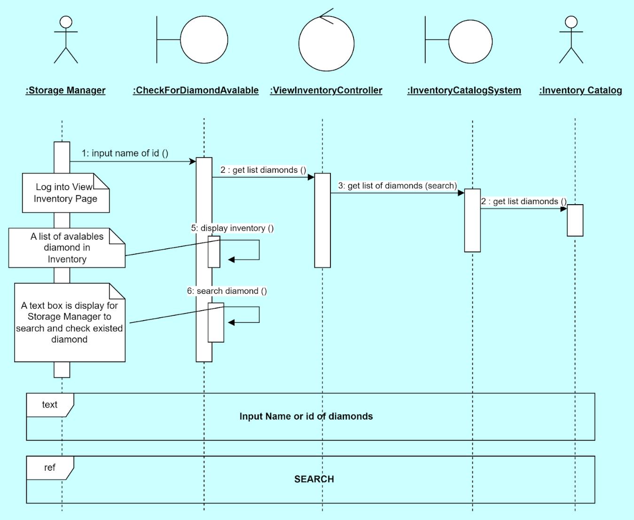

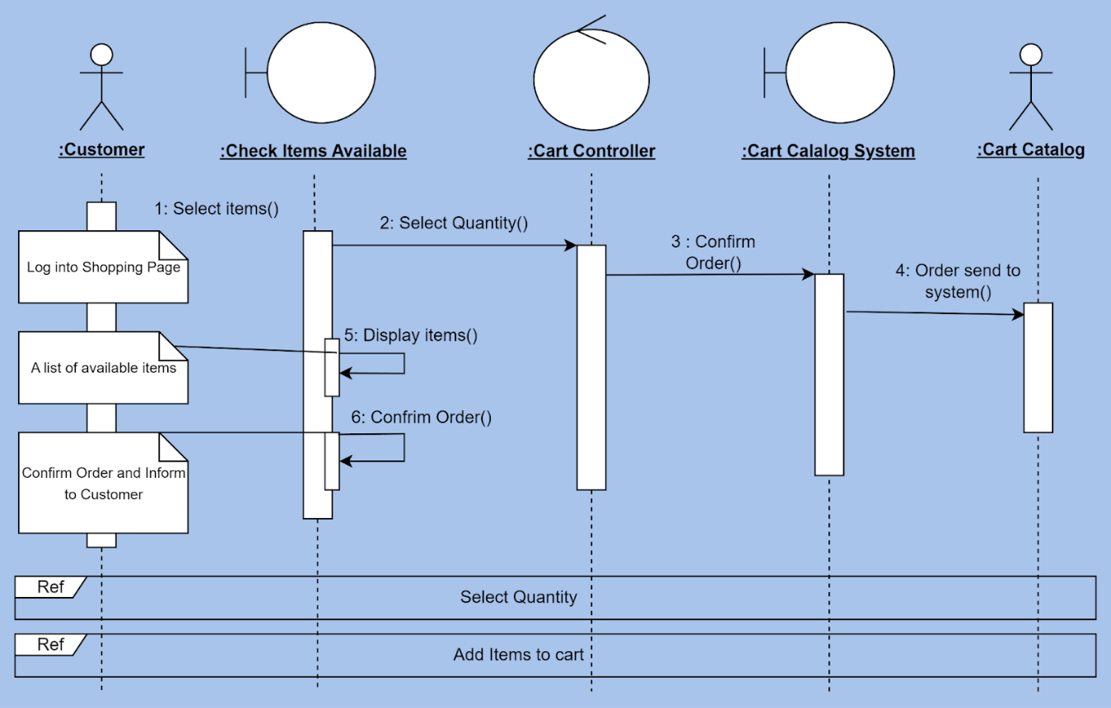

**Data dictionary**

|  |  |  |  |  |
| --- | --- | --- | --- | --- |
| Data Element | Description | Composition or Data Type | Length | Values |
| ProductID | A unique identifier for each product in the inventory system. | String | 6 | Not null |
| ProductName | Provides a human-readable identifier for each product, facilitating easy recognition and differentiation of products within the dataset. | Alphanumeric characters, spaces, and basic punctuation | 12 |  |
| Description | A detailed description of the product. | String | <255 character |  |
| Price | The selling price of the product. | Float | 10 |  |
| Discount | Any discount applied to the product. | Float | 4 |  |
| ShippingCost | The cost of shipping the product. | Int | 7 |  |
| Images | URLs or file paths to images of the product. | List/Array of Strings | 255 |  |
| Brand | The brand of the product. | String | 10 |  |
| Manufacturer | The model number of the product. | String | 255 |  |
| ReleaseDate | The date when the product was released. | date | 10 |  |
| CustomerID | A unique identifier for each customer. | String | 12 | Not null |
| FirstName | The customer's first name. | String | 5 |  |
| LastName | The customer's last name. | String | 5 |  |
| Password | The encrypted password for the customer's account. | String | < 20 |  |
| PhoneNumber | The customer's phone number. | Int | 13 |  |
| ShippingAddress | The customer's shipping address (if different from billing). | String | < 255 | Not null |
| ShoppingCart | The current contents of the customer's shopping cart. | String |  |  |
| OrderHistory | A list or reference to the customer's past orders. | String |  |  |
| Wishlist | A list of products the customer has added to their wishlist. | List/Array | < 255 |  |
| DateOfBirth | The customer's date of birth. | date | 10 |  |
| Gender | The customer's gender. | boolean | 1 |  |